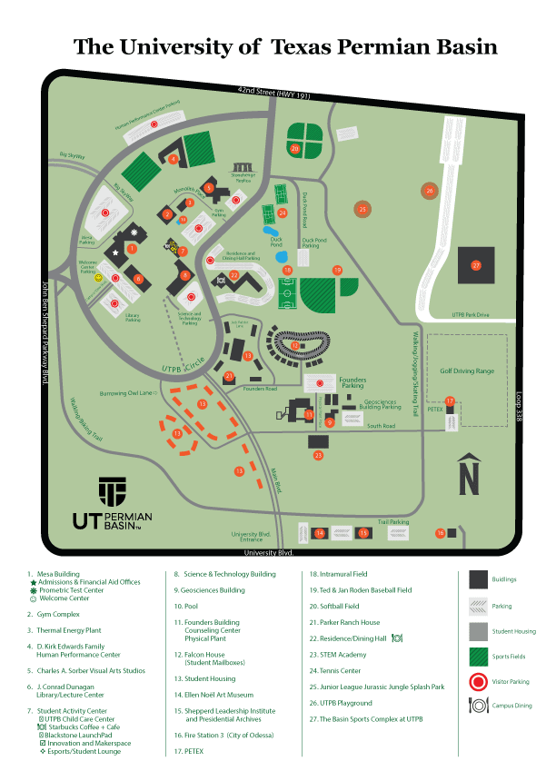
ODESSA CAMPUS MAP
MIDLAND CAMPUS MAP
